Welcome to
Seeking Origins: Puzzle Hunt of IliAd
- This is not a stressful closed-book exam. Feel free to consult search engines like Google and the Iliad if needed.
- This set of puzzles is based on Richmond Lattimore’s translation (University of Chicago Press, 2011 edition). Most Greek words follow the spellings in this book, though some use other common spellings.
- This puzzle hunt includes 6 puzzles plus 1 metapuzzle. Finish at least 4 puzzles to unlock the metapuzzle.
- The answer to each puzzle is a word or phrase written in Latin letters (not necessarily English).

PROLOGUE
To study the era recorded by Homer in the field, you take the CLCV (Classical Cipher Voyager) 115 space-time machine to ancient Greece. However, for some reason, a serious rift appeared in space-time, and you are transported to a “complex number space-time” that has not been studied. The time displayed on the dashboard is “(1184+3209i) BCE.”
When you get out of the cabin, there are no other people around—of course no deities either. And the scene is so chaotic... There are some remains of an ancient city in the distance, which looks a little broken but not as old as it was weathered for thousands of years. There are somethings that obviously look like modern crafts nearby, but at the same time, several ancient Greek-style bronzes that had not yet rusted were scattered on the ground. Looking around, you can see fragments of wares with Linear B glyphs, Greek in various historical fonts, Latin letters, ... even emojis?! This makes you completely unable to judge what era it is now. The timeline seems to be distorted and overlapping. “Uh, yeah... minus 1184 plus 3209 is 2025...” You try to think, but you find that your brain just goes blank.
Then you try to locate yourself and find yourself on an island in the Aegean Sea, but this island does not even exist on the map. What’s worse, you find that you have lost your memory and cannot remember the purpose of coming here. Only by recalling what you want to investigate can you have a chance to correct the space-time machine and return to the correct time and space.
𐀂 ARROWS
You approach the ancient city ruins ahead and spot a billboard on the gate that appears entirely modern, displaying this image.
You can't help but wonder, what place is this? Who once lived here?

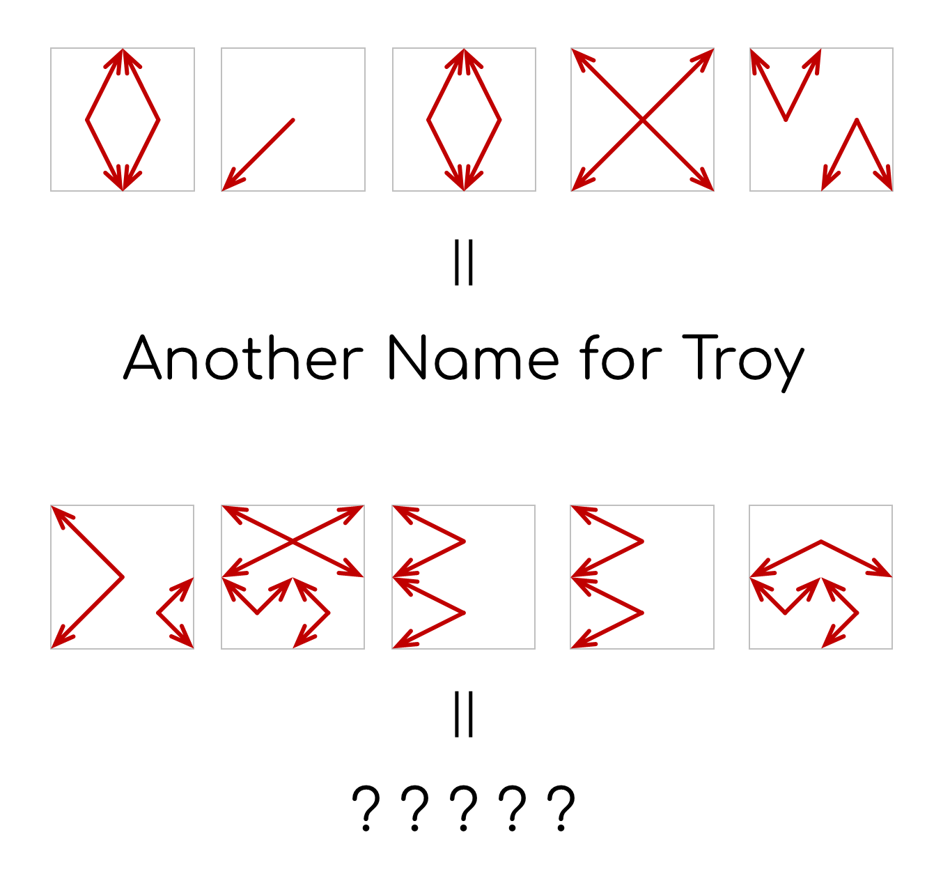

𐀃 NONOÖBOL
On the sandy beach, you discover some fragments of papyrus.
Their patterns remind you of a familiar logic puzzle.

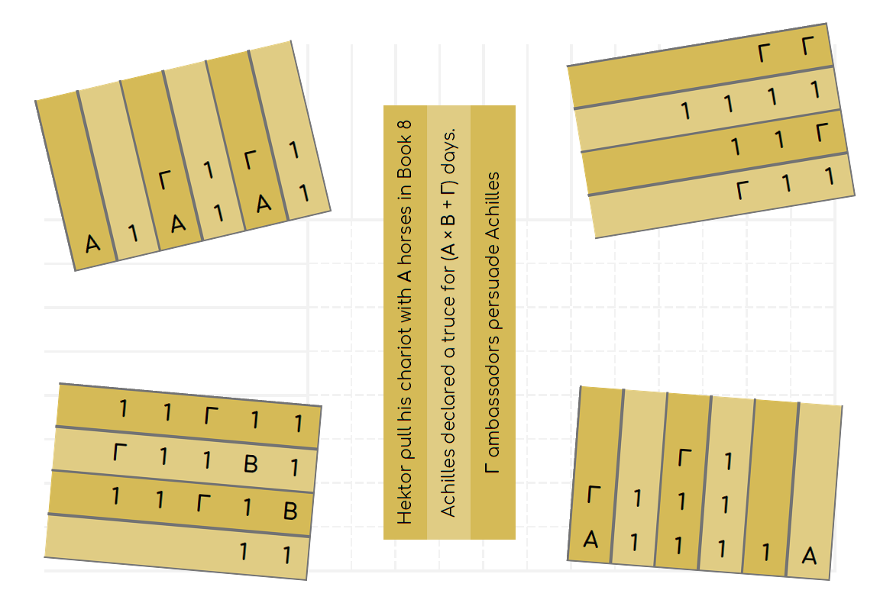

𐀀 SLAY THE TROJANS
On a hillside, you spot a wax-coated wooden tablet that at first glance resembles Achaians’ battle notes. Your portable translator renders it into English. But it looks somehow weird.
Regardless, you decide to uncover the secret hidden in it.
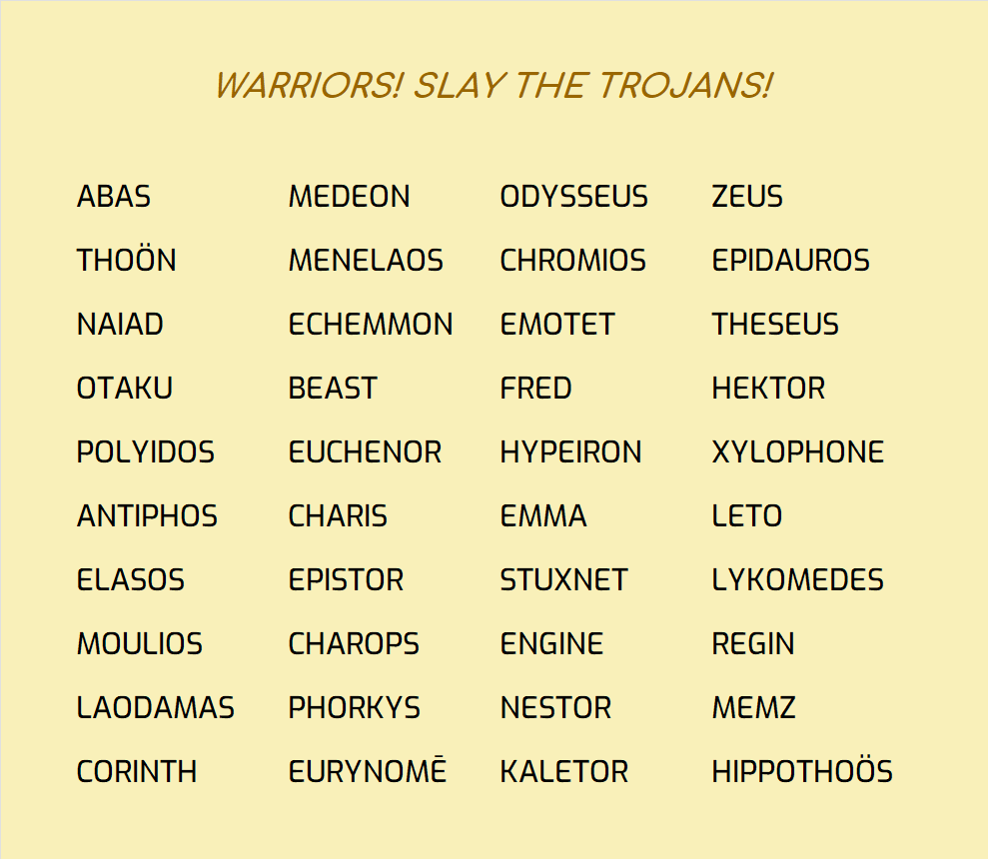
(6 2 10)

𐀲 CROSS LÉXI
You discover a terracotta crater in a cave. Its front is painted with such a grid pattern.
You also find a scroll of parchment inside the crater. It is a crossword!?
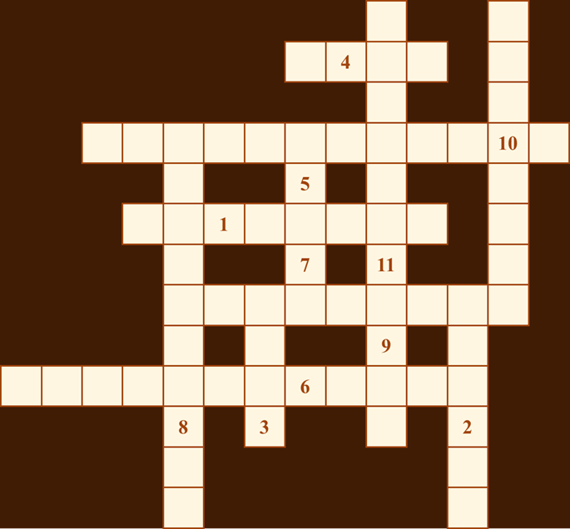
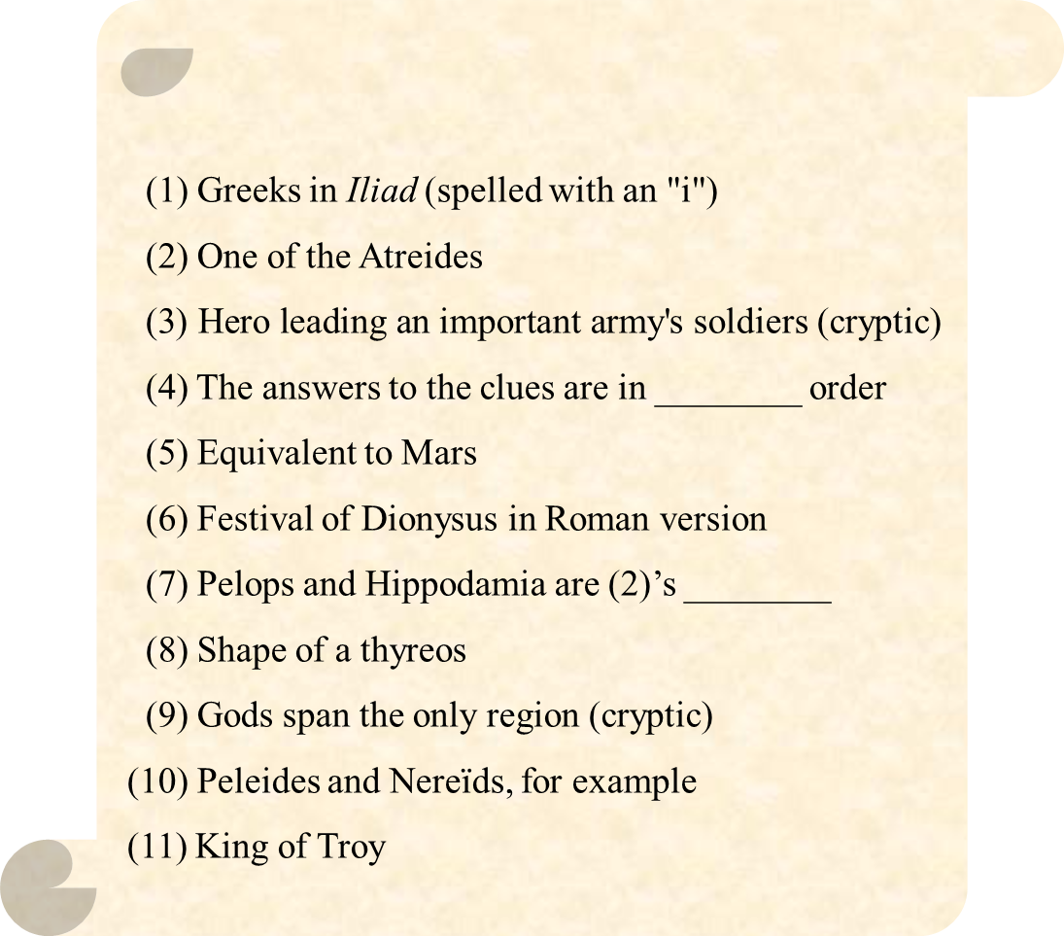
𐀠 DROPCITE
At the southern cape of the island, you discover a stone tablet.
To find the answers, you must first determine where these inscriptions come from.
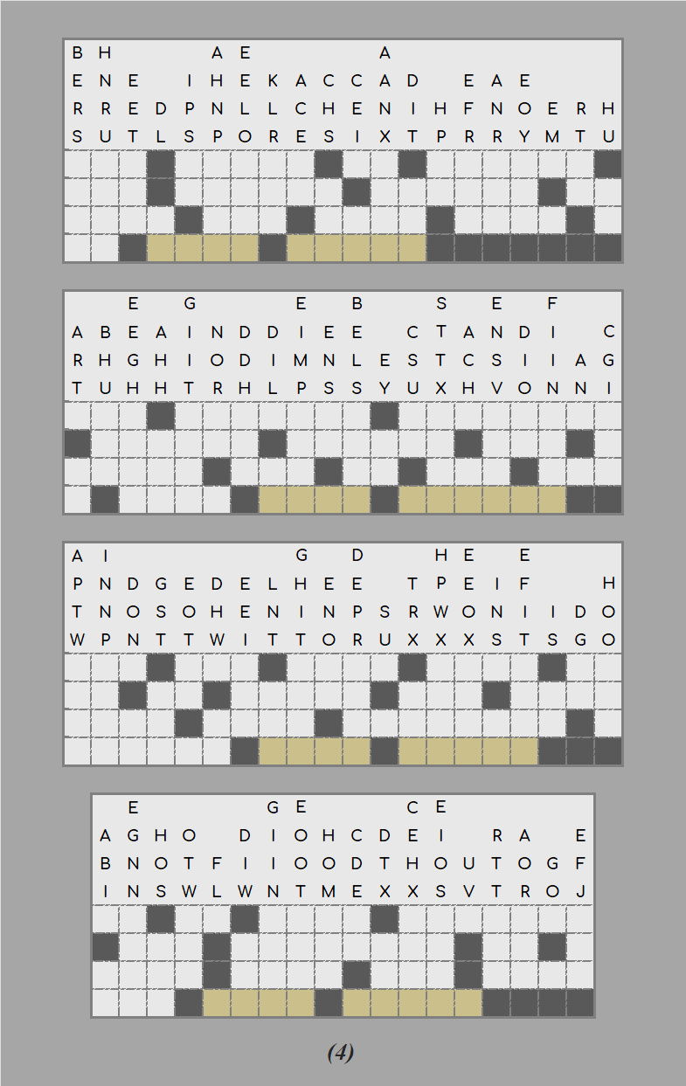
𐀁 EXPLORATION
Beneath a laurel tree, you discover a series of instructions written on clay tablets. Your translator converts them into English.
They guide you to continue your exploration.

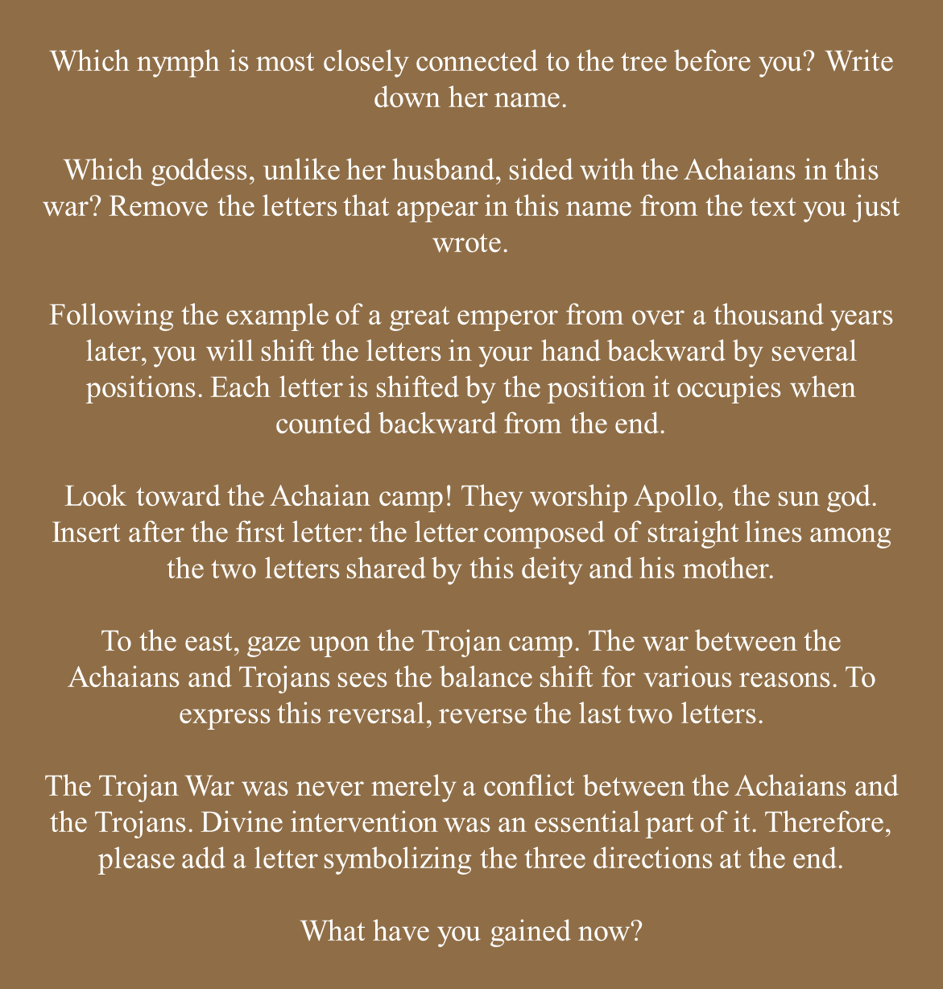

𐀕 ΜΕΤΑ
META
防 剧 透
（原文件不含这个）
After exploring nearly the entire island, you return to your space-time machine you’re your astonishment, you discover that a broken pristine white stone tablet had appeared beneath its support frame—you distinctly remember it wasn’t there when you left the machine.
“Anyway, it’s time to piece everything together,” you say to yourself.

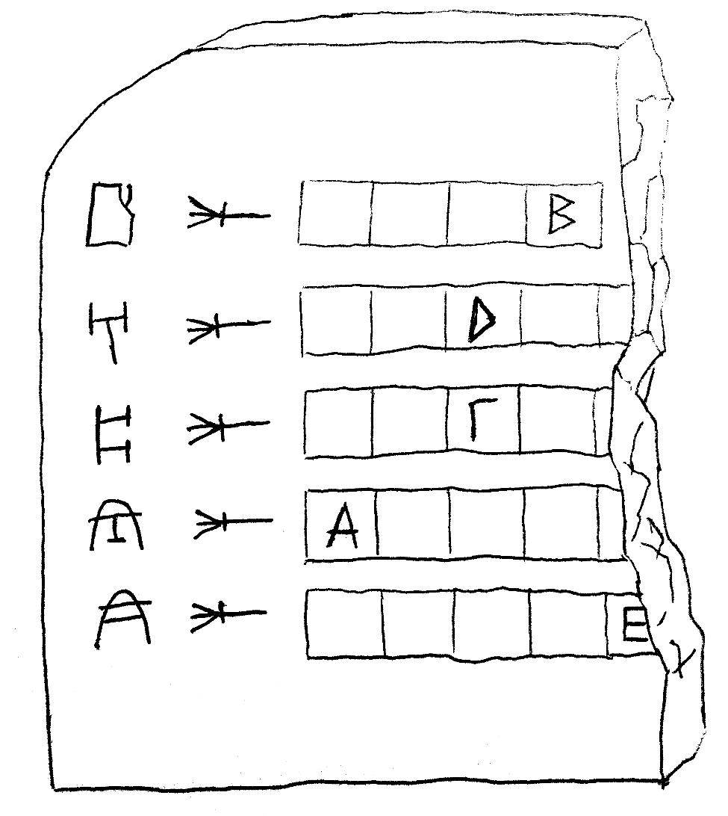

THE END
THE END
防 剧 透
（原文件不含这个）
After gathering your thoughts, the final answer emerges in your mind.
MĒNIS (ΜΗΝΙΣ).
In an instant, all the memories lost due to the time-space misalignment flooded back into your mind. Indeed. The opening lines of Book 1 of the Iliad have long made clear its central theme:
“Sing, goddess, the anger of Peleus’ son Achilleus…”
You recall that you came here specifically to investigate the impact of Achilles’ wrath on the entire course of the Trojan War. Meanwhile, the core focus of your investigation exactly lies in timē, xenia, kleos, and other elements emerging from each puzzle you met.
You entered this message into the intelligent system of the space-time machine. The space-time machine successfully decoded and commenced autonomous navigation. The space-time machine emitted violent vibrations. In an instant, the scenery outside began to rush by, soon transforming into an extremely blurred haze of light. After a while, everything returned to stillness.
You glance at the dashboard. The year is 1184 BCE, the final year of the Trojan War. Your coordinates place you within a dozen miles of Troy. Looking out, you see the Achaians’ encampment. Everything is in order. You begin your investigation as planned...

Puzzle | No. | Hint (cut before distribution)
Arrows | 1 | How should I get started?  The pattern formed by the arrows in each square can be converted into a letter pattern according to a specific rule.
Arrows | 2 | Can you hint more?  The pattern above gives a 5-letter word ending with “ON”.
Nonoöbol | 1 | What does the title mean?  Obol is a small ancient Greek weight unit, roughly the same order of magnitude as a gram. Thus, the title means “nonogram.”
Nonoöbol | 2 | Can you just tell me what Α, Β, and Γ are?  They are 4, 2, and 3 correspondingly.
Slay the Trojans | 1 | What should I do?  Delete all the Trojans in the array.
Slay the Trojans | 2 | What should I be mindful of?  Computer trojans are also considered Trojans.
Slay the Trojans | 3 | How should I extract the answer?  Read the initial letters of the remainders.
Cross Léxi | 1 | How should I fill it out?  Unlike common crosswords, it does not indicate the starting position or direction for each entry. You need to determine where each word should be placed based on the shared letters.
Cross Léxi | 2 | Which characteristic of each clue’s answer can help me fill it in?  Note clue number 4. These answers are sorted by a common method. This allows the range of each answer to be constrained by adjacent answers.
Drop Cite | 1 | How should I get started?  These are four dropquotes. You need to fill in the letters above in the appropriate positions within the column to complete a sentence or paragraph.
Drop Cite | 2 | What should I do next?  Identify which Book each one is quoted from and apply a simple conversion.
Exploration | 1 | How should I get started?  The tree required for the first instruction is found in the flavor text—the text between the title and the instruction.
META | 1 | How should I deal with the answers from previous puzzles?  You need to convert the answers to the corresponding puzzles in some way and then fill them in.
META | 2 | I still don’t understand. Can you give an example?  PRIDE → HYBRIS.

